

INTERNATIONAL SOCIAL SERVICE - BULGARIA

INTERCOUNTRY CASEWORK

REPORT

2009

І. Inter-country casework 2002 – 2009
Inter-country casework is amongst the priorities of ISS-Bulgaria since 2002.
Between 2002 and 2009, ISS-Bulgaria has worked on 282 cases, of which 213 are closed and 69 are still pending:

The table provides information as per 31.12.2009

Period  (years) | Registered  cases | Pending  cases | Closed  cases
2002 - 2004 | 75 | 0 | 75
2005 | 34 | 1 | 33
2006 | 42 | 1 | 41
2007 | 29 | 10 | 19
2008 | 46 | 13 | 33
2009 | 56 | 44 | 12
Total: | 282 | 69 | 213

ІІ. Inter-country casework in 2009
In 2009, ISS-Bulgaria has had 105 cases in total, of which:
56 newly registered for 2009,
13 pending cases from 2008,
10 pending cases from 2007,
1 pending case from 2006,
1 pending case from 2005,
23 cases from 2008, that has been closed in 2009, and
1 case from 2007, that has been closed in 2009

Cases (problem types) in line with the ISS consolidated problem codes
for the period 01.01.2009 – 31.12.2009
Category | Type of service | Number of cases
Adoption | Total | 8
Adoption | Assessment of the capacity of the candidates to become adopters | 2
Adoption | Consultancy | 2
Adoption | Home study | 2
Adoption | Post-adoption monitoring | 2
Welfare of adults | Total | 1
Welfare of adults | Consultancy | 1
Welfare of children | Total | 29
Welfare of children | Placement with relatives or close friends | 2
Welfare of children | Parental rights and obligations | 3
Welfare of children | Right of access / contact | 1
Welfare of children | Child abduction | 6
Welfare of children | Child at risk | 10
Welfare of children | Parental rights and obligations (exercise of parental rights and obligations and right of access) | 6
Welfare of children | Guardianship | 1
Welfare of children | Consultancy | 1
Legal assistance | Total | 2
Legal assistance | Documentation | 1
Legal assistance | Legal aid | 1
Legal assistance | Repatriation | 1
Family tracing and reunion | Total | 16
Family tracing and reunion | Family reunification | 7
Family tracing and reunion | Tracing and reunification  (known family) | 7
Family tracing and reunion | Tracing (post adoption) | 1
Family tracing and reunion | Tracing and reunification  (unknown family) | 2
Total of all cases |  | 56

Number of cases as per origin of the signal
(number of requests referred to the ISS Bulgaria)
for the period 01.01.2009 – 31121.2009
Country | Individual / Legal entity | Number of cases
Bulgaria | Total | 45
Bulgaria | SACP / ASA | 5
Bulgaria | DSA / CPD | 26
Bulgaria | Courts | 2
Bulgaria | Individuals | 8
Germany | Total | 3
Germany | ISS network | 3
Spain | Total | 3
Spain | ISS network | 1
Spain | Individuals | 2
Greece | Total | 1
Greece | ISS network | 1
Italy | Total | 1
Italy | Individuals | 1
Australia | Total | 1
Australia | Individuals | 1
Romania | Total | 1
Romania | ISS network | 1
USA | Total | 1
USA | ISS network | 1
Total number |  | 56

Number of cases as per destination of signal
(number of requests referred from the ISS Bulgaria)
for the period 01.01.2009 – 31.12.2009
Country | Legal entities | Number of cases
Bulgaria | Total | 11
Bulgaria | DSA / CPD | 5
Bulgaria | ISS network | 2
Bulgaria | Others | 2
Greece | Total | 13
Greece | ISS network | 13
Spain | Total | 6
Spain | ISS network | 6
Germany | Total | 4
Germany | ISS network | 4
Italy | Total | 4
Italy | ISS network | 3
Italy | Others | 1
France | Общо | 3
France | Мрежата на МСС | 2
France | Други | 1
Cyprus | Total | 2
Cyprus | ISS network | 2
USA | Total | 2
USA | ISS network | 2
Portugal | Total | 1
Portugal | ISS network | 1
Belgium | Total | 1
Belgium | ISS network | 1
Austria | Total | 1
Austria | ISS network | 1
Netherlands | Total | 1
Netherlands | ISS network | 1
Lebanon | Total | 1
Lebanon | ISS network | 1
Switzerland | Total | 1
Switzerland | ISS network | 1
Syria | Total | 1
Syria | ISS network | 1
Turkey | Total | 1
Turkey | ISS network | 1
United Arab Emirates | Total | 1
United Arab Emirates | ISS network | 1
United Kingdom | Total | 1
United Kingdom | ISS network | 1
Australia | Total | 1
Australia | ISS network | 1
Total number |  | 56

ІІІ. Other activities related to inter-country casework
In 2009, ISS-Bulgaria commenced an awareness campaign with respect to the ISS opportunity to assist and support inter-country casework. Contacts with regional and district courts, BAR Associations, trainings of different professionals and International Conference were carried out in the frame of this campaign.

Training of lawyers
In April 2009, ISS-Bulgaria sent letters to all 27 BAR Associations in the country proving information about ISS-Bulgaria as an organisation and presentation of the opportunities for support and assistance in inter-country casework. There was a proposal for a training seminar for all lawyers registered in the respective BAR Association.
In June, upon request of Veliko Tarnovo BAR Association, the first training seminar was organized. 25 lawyers took part in the event. The seminar included 4 sessions: 1) Presentation of ISS as an international network of organisations, 2) Presentation of ISS-Bulgaria and in particularly inter-country casework, 3) Mechanisms for support and assistance (who can refer to the ISS-Bulgaria and how ISS-Bulgaria can assist), and 4) Discussion of cases from the practice of the lawyers.

Training of judges, social workers and other professionals within the ‘Roadshow 2009’ initiative
In October, within the ‘Roadshow 2009’ initiative, organised by ‘Children’s Legal Centre-Bulgaria, a training of different professionals was carried out. The Roadshow programme for judges, enforcement judges, social workers, psychologists, teachers, doctors, staff of specialized institutions for children and other professionals, included one special session devoted to the ISS-Bulgaria inter-country casework as well as the opportunities for support and assistance. The seminars were organized in Silistra, Dobrich, Varna, Razgrad, Ruse and Pleven. There were 142 professionals in total, of which 65 judges from regional and district courts including enforcement judges, 60 social workers and other representatives of the Agency for Social Assistance as well as other experts such as teachers, NGO representatives, two foreigners – social workers and etc.

International Conference ‘The best interest of the child in inter-country casework’
ISS-Bulgaria in conjunction with the ISS-German Branch with the financial support of the German Ministry of the family, elderly, women and youth, organised international conference ‘The best interest of the child in inter-country casework. Assistance and cooperation by ISS in searching and finding solutions’
The conference was held on 10th and 11th of December 2009 in Anel Hotel, downtown Sofia. Seema Pannaikadevil, assistant of Mr. Sean Ayoub, ISS General Secretary, Ursula Roelke and Frank Hartwig from the ISS-German Branch took part in the conference from the side of the ISS network. Verena Clausen-Schmidt, a practicing family judge from the Court in Berlin also participated in the conference. There were many and different professionals from the Bulgarian side that took part in the event - representatives from the Ministry of Justice, Ministry of Labour and Social Policy, Ministry of Foreign Affairs, State Agency for Child Protection, Agency for Social Assistance, Bulgarian Ombudsman, Child Protection Departments in Ruse, Shumen and Blagoevgrad, judges from Sofia regional and district courts, judges from Burgas and Gabrovo, lawyers as well as clients of ISS-Bulgaria.
34 different professionals took part in the conference. The event was opened by Mrs. Nadya Shabany, chair of the State Agency for Child Protection. Mrs. Valentina Simeonova, deputy minister of Labour and Social Policy sent a message of congratulation to the participants whereas Mrs. Daniela Masheva, deputy minister of Justice closed the conference.
The conference was aiming at presentation of ISS as an international network of organisations, opportunities of the organisation to provide support and assistance in inter-country cases between different countries through their courts and social services and individuals as well. Special focus was given to the practice of ISS-Bulgaria from 2002 up to now.
The main issues discussed during the Conference reflected the practical application of the international and internal legislation regarding exercise of parental responsibility, the right of access / contact, international child abduction as well as recognition and implementation of a foreign judgment concerning child protection measures.
The Conference was reflected by both the German and the Bulgarian media – Deutsche Welle-Germany, Bulgarian National Radio, Deutsche Welle-Bulgaria, Radio Blagoevgrad and Zaman newspaper.

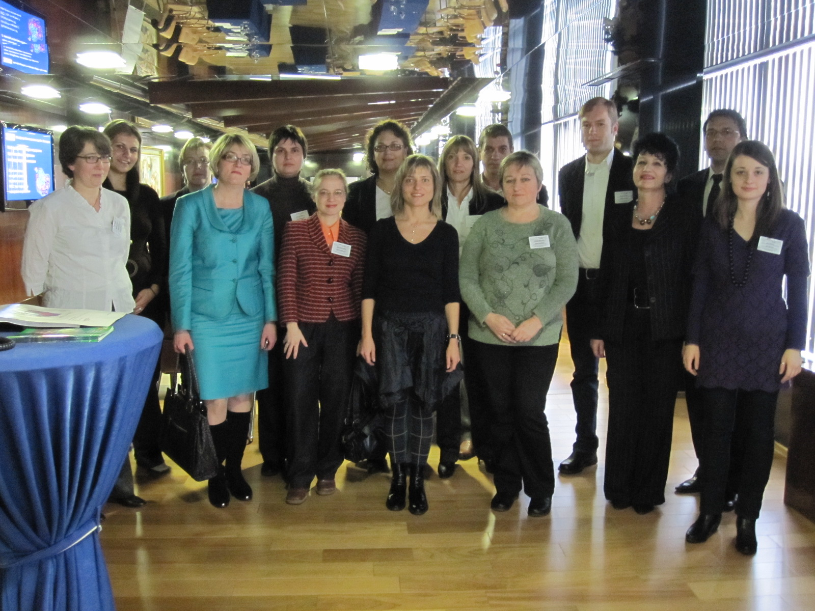
Participants with the Bulgarian deputy minister of Justice, Mrs. Daniela Masheva

State Agency for Child Protection
Agency for Social Assistance
Directorate for Social Assistance
Child Protection Department

